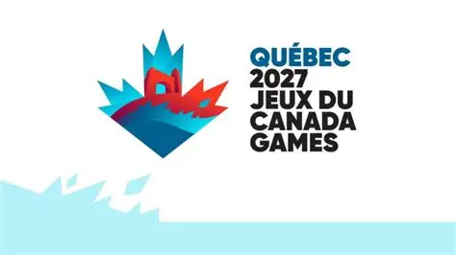
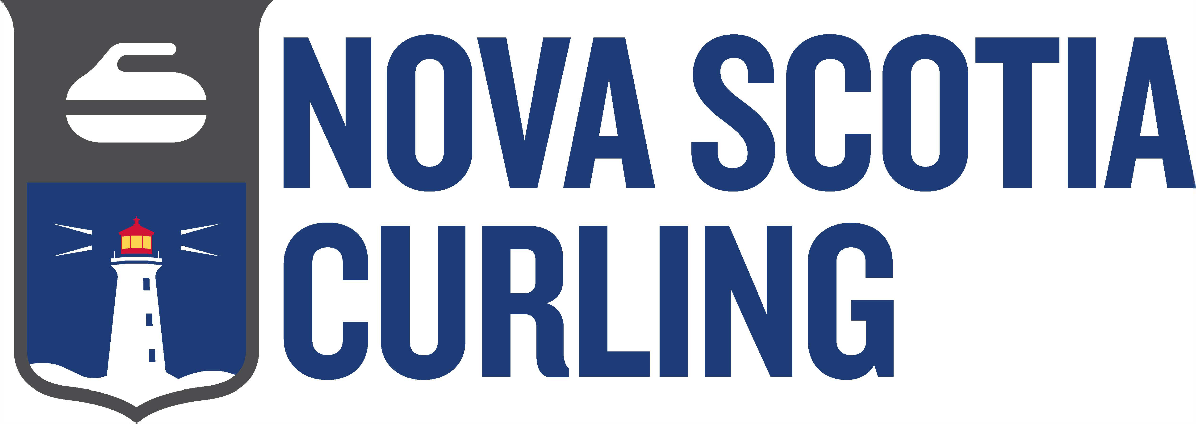
2027 Canada Winter Games
Coaching Requirements

In the 2026 season Nova Scotia Curling will host three qualifiers for the 2027 Canada Winter Games. The Mixed Doubles championship will take place from March 12-16 at the Berwick CC. The Boys and Girls Championship will take place at the Mayflower Curling Club from April 2-6.
To coach at these provincial events the requirement is the same as coaching at our U-18 provincial events, Competition Coach - in training (Competition Coach Workshop + MED Workshop +/- evaluation). To review additional coaching information please go to Section 8 on page 10 to review our coaching guidelines.
If your team is successful in winning the right to represent NS at the 2027 Canada Winter Games the coach will be required to complete a higher coaching level. Coaches will have up to 45 days prior to the Games to complete the requirements. This requirement includes becoming - Competition Development in Training (Certified Competition Coach + completion of “Manage A Program” and “Health and Wellness” Curling Canada modules and Managing Conflict Module”. If coaches are interested in entering Competition Development prior to the CWG playdowns they can reach out to Jennifer Ferris at Curling Canada.
To find out more about coaching at the 2027 Canada Winter Games their Technical Package is available.
If you have additional questions please reach out to NS Curling’s Technical Director Jill Brothers.
Jill Brothers
jbrothers@nscurl.com
902-489-8867
Technical Director

