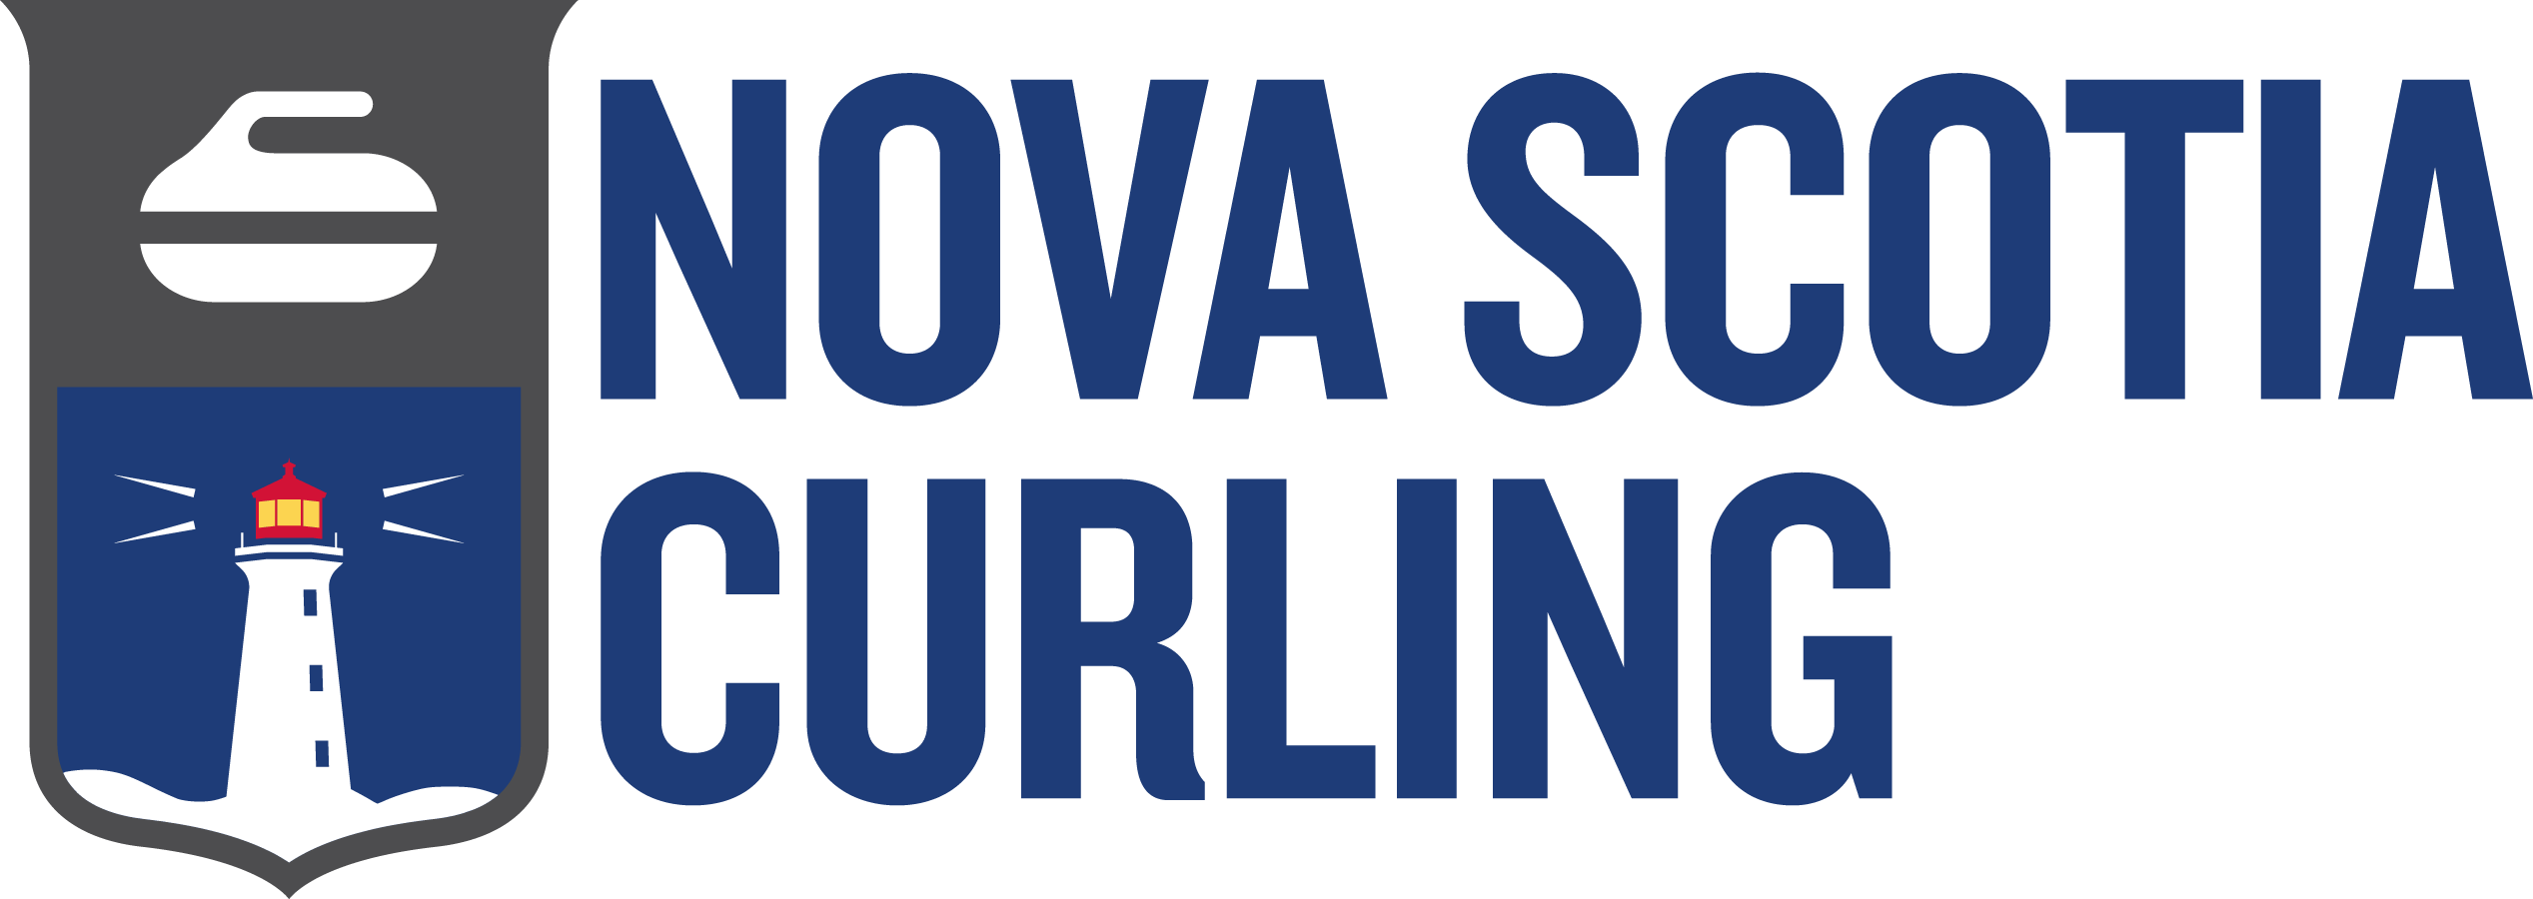
2026-2027
PROVINCIAL CHAMPIONSHIP CALENDAR

Event | Dates | Host (years) | Registration Deadline | Canadian Championship

Tier 1 (Leads to a World Championship)
Women’s Open Qualifier & Men’s Open Qualifier | Dec 10-13/26 | Amherst (1) | Nov 5, 2026 | N/A
Women’s Provincial &  Men’s Provincial | Jan 12-17/27 | Mayflower * | Qualifying Event | Feb 12-21/27  Feb 26-Mar 7/27
Under 20 (M & W) | Feb 2-6/27 | Halifax * | Dec 30, 2027 | Mar 20-27/27
Mixed 4-Player | Mar 11-14/27 | Digby (2) | Feb 4, 2027 | Nov 8-14/27
Senior (M&W) | Mar 17-21/27 | Digby (1) | Feb 3, 2027 | Dec 5-12/27
Mixed Doubles | Mar 17-21/27 | Liverpool (3) | Feb 3, 2027 | N/A
AUS championship is Jan 21 - 24, 2027 at CFB Halifax CC.
Canada Winter Games are Feb 26-Mar 15, 2027, in Quebec City

Tier 2 (Leads to a National Championship)
Under 18 (B & G) | Feb 17-21/27 | Kentville (1) | Jan 6, 2027 | Apr 18-24/27
Masters (M & W) | Feb 24-28/27 | Amherst (1) | Jan 13, 2027 | Apr 5-11/27
Wheelchair | Feb 26-28/27 | Lakeshore (1) | Jan 29, 2027 | Apr 19-24/27
Men Club Championship | Mar 4-7/27 | Lakeshore (1) | Jan 20, 2027 | Nov 24-29/27
Women Club Championship | Mar 25-28/27 | Sydney (2) | Jan 20, 2027 | Nov 24-29/27

Tier 3 (NSCA Championship)
U-15/U21 Mixed Doubles | Jan 14-17/27 | Westville (1) | Dec 3, 2026 | N/A
U-15 NS Rockfest Atl, NS Qualifier #1 | Jan 28/27 | Bridgewater (1) | Dec 30, 2026 | Mar 25-27/27
Under 15 (B & G) | Jan 28-31/27 | Bridgewater (1) | Dec 30, 2026 | N/A
Club Series (M & W) | Feb 4-7/27 | Digby (3) | Jan 4, 2027 | N/A
U-15 NS Rockfest Atl, NS Qualifier #2 | Feb 13/27 | CFB Halifax (1) | Jan 13, 2027 | Mar 25-27/27
Club Series Open (U15/U21) | Mar 5-7/27 | Windsor (3) | Feb 3, 2027 | N/A
Club Series Mixed | Mar 11-14/27 | Amherst (1) | Feb 10, 2027 | N/A
U-15/U-21 Mixed 4-Player | Mar 19-21/27 | Truro (1) | Feb 24, 2027 | N/A
Updated: Sept 19, 2026

Tier 4 (Participation Bonspiel)
U-12 Jamboree (4’s) | Feb 13-14/27 | Dartmouth (1) | Jan 13, 2027 | N/A
U-12 Hit Draw Tap | Mar 7/27 | Lakeshore (1) | Feb 5, 2027 | N/A
U-9 Triples Jamboree | Mar 20/27 | Windsor (3) | Feb 24, 2027 | N/A
U-12 Triples Jamboree | Mar 21/27 | Windsor (3) | Feb 24, 2027 | N/A
Grandmasters (M&W) | Mar 30-Apr 2/27 | Dartmouth | Feb 25, 2027 | N/A

Associate Organizations
Stick Association (M&W) | Jan 21-24/27 | Yarmouth (2) | Dec 15, 2026 | Mar 30-Apr 3/27
Stick Association (Mixed) | Feb 19-22/27 | Truro (2) | Jan 26, 2027 | Mar 30-Apr 3/27

*Four-year agreement alternating the U-20 Championship and the Men’s and Women’s Championship between Mayflower CC and Halifax CC from the 2026-2027 season to the 2029-2030 season
Event dates consider the traditional number of teams, minimizes time off school and work, and maximizes club availability. NS Curling will confirm the exact number of days required after the registration deadline.

This calendar is published by the Competitions Advisory Pannel (CAP). Please address any questions or feedback to competitions@nscurl.com.

