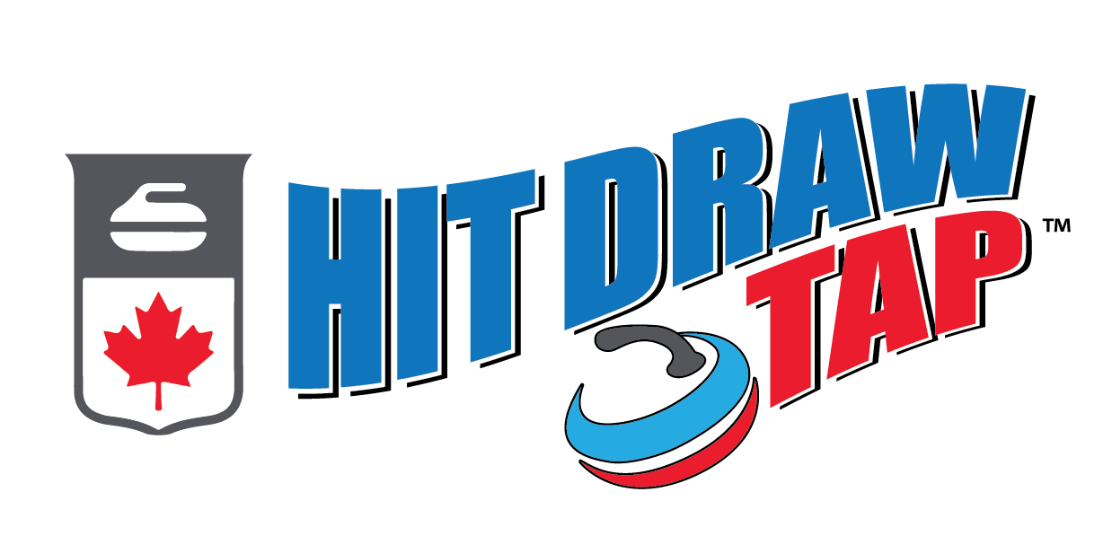

NS Curling Hit Draw Tap Program
Nova Scotia Curling and Curling Canada is looking forward to another season of Hit Draw Tap.
Hit Draw Tap (HDT) is a youth skills competition where kids ages 6-12 compete as individuals. HDT will group kids into three different age categories (6-7, 8-9 & 10-12), and perform three different shots – a “Hit,” a “Draw” and a “Tap.” The difficulty of the skills is modified based on the age of the child. Curling centers across Nova Scotia are encouraged to run 5 HDT competitions as part of their Junior Program whenever it best suits them.
Between Nov 1st and Feb 7th curlers will participate in HDT at their home clubs (those participating). All participants will be able to see where they rank on the Curling Canada Leaderboard. On Monday, Feb 8th the top 5 participants from each age group will be invited to compete in the Hit Draw Tap Provincial Championship. The event will take place on March 7th, 2027, at the Lakeshore Curling Club in Sackville.
*If your child/curler qualifies for the event at Lakeshore please confirm with Jill Brothers if they will be attending or not by Feb 21rd , 2027.
For more information go to - www.curling.ca/hitdrawtap
Or contact your local Junior Program Director
Or NS Curling’s Technical Director Jill Brothers:
jbrothers@nscurl.com
902-489-8867

